Nepal College of Information Technology
Assessment
Fall 2009
Program: ELX-V Time: 3 hrs
Semester: Fall FM: 100
Subject: Control Systems PM: 50
Attempt ALL the questions.
1. a) Differentiate between open loop and closed loop control systems. [6]
b) A mechanical system is represented as shown in the figure below:
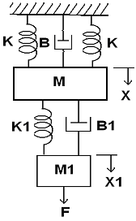
Obtain the mechanical equations and also draw the force voltage analogy and force current analogy of the given system. [9]
2. Obtain the overall transfer function of the system shown in the figure using bothsignal flow graph technique and block diagram reduction technique. [15]
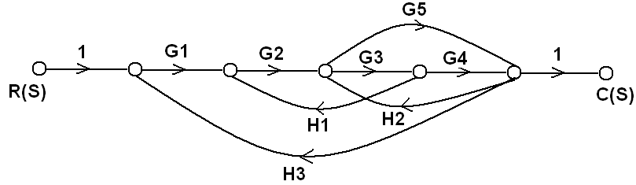
3. a) A closed loop system is shown in below
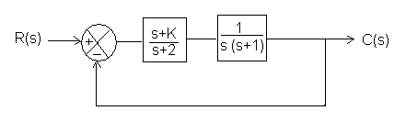
Using Routh Criteria calculate the values of K for which the system is stable. [7]
b) Draw the overall block diagram for armature controlled DC motor. Also find the overall transfer function. [8]

4. a) Determine the state model for the electrical circuit shown in the figure. Represent i(t) and V₀ as state variables. [7]
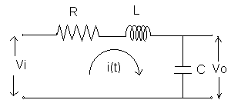

b) Obtain the state model for the transfer function given below
Y(s)/U(s) = ( s²+3s+1)/ (s³+ 8s² +25s +24)
Use direct decomposition method. [8]
5. a) The open loop transfer function of a unity feedback control system is given by
G(s)= K/{s(1+sT)}
Determine the value of K& T that will give the Maximum overshoot of 5% and the settling time (2%) of 2 second for the unit step input. [8]
b) The open loop transfer function of a unity feedback control system is given by
G(s)=K/{s (s+2) (s+10)}. Find the static error constant and steady state error of the system when subjected to input
r(t) = 1 + t + (t²/2) [7]
6. Sketch the root locus for the open loop transfer function of a unity feedback control system given below whose open loop transfer function is given by
G(s)H(s)= k / {s(s+3) (s²+2s+2)} [15]
7. Write short notes on (Any two): [5*2=10]
a) Relative stability and absolute stability
b) Encoders
c) Rise time (tr) for a second order system

